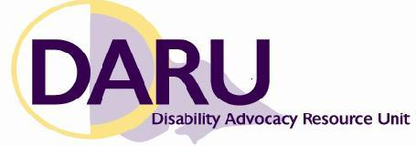

Advocacy Sector Conversations

Forum 1 Agenda

Tuesday 22 October 2013

Queen Victoria Women’s Centre,

Victoria Room, Level 4,

210 Lonsdale Street, Melbourne
11:15 – 11:30 | Registration
11:30 – 11:45 | Welcome and introductions
11:45 – 12:30 | Session 1: Safeguarding the rights of people with disability
John Chesterman, Manager Policy and Education, from the Office of the Public Advocate will deliver a presentation on the Interagency Guidelines for Addressing Violence, Neglect and Abuse (IGUANA) which was launched in May. The guidelines were developed in collaboration with representatives from the disability and mental health sectors, statutory agencies, family violence and sexual assault services, and the Victorian Police.
12:30 – 1:30 | Lunch and networking
1:30 – 2:30 | Session 2: Building partnerships
Earlier this year, the Victorian Equal Opportunity and Human Rights Commission (VEOHRC) worked in partnership with DARU to deliver training for disability advocates on delivering a human rights approach to advocacy. Wendey Sanderson, Senior Adviser Strategic projects, from VEOHRC will provide an overview of the Commission’s current projects. She will also speak about the work of the Commission’s disability reference group and how people can become involved.
2:30 – 2:35 | Stretch break
2:35 – 3:15 | Session 3: Developing disability advocacy
Melanie Muir, Senior Advocate at Leadership Plus and Disability Advocacy Victoria Board member, will deliver a presentation on the value of a peer network for disability advocates. Melanie has established a network to support advocates to learn from each other and provide a forum for debriefing and building resilience.
3:15 – 3:45 | Session 4: Q&A with Office for Disability
This session will be an open forum to allow people to raise any issues of concern with representatives from the Office for Disability.
3:45 – 4:00 | Where to from here?

